**What is the City Ai Engine?**

The City AI Engine is a practical tool designed to improve city management by making the most of data and artificial intelligence. It gathers various types of information from different parts of the city, everything from demographics to consumption patterns to public service usage and analyzes it to help city officials , citizens and any stakeholder understand what's happening on the ground. This helps them make informed choices about where to allocate resources, how to address city-wide issues, and plan for future needs.

The system is all about making city operations more transparent and effective. By using real data from various sources , it ensures that decisions are based on what's actually needed rather than guesses. Whether it’s fixing roads, planning new parks, or improving safety, the City AI Engine provides a clear picture of the city's needs. Ultimately, this leads to better services and a better living environment for everyone in the city.

**Objectives**

* To integrate disparate data sources from various city departments into a single, accessible platform.
* To build a digital twin of the city that mirrors real-life conditions and simulates the impact of potential decisions.
* To improve transparency and engagement with the public through interactive and informative visual tools.
* To develop an AI-driven analysis system that can predict trends, detect anomalies, and provide strategic insights.

**Key Components**

**Data Aggregation:**

Collect and consolidate data from multiple sources, including public records, sensors, and satellite imagery. This data will be converted into standardized formats like [GeoJSON](https://geojson.org/) or GeoXML to facilitate easier manipulation and analysis.

**AI Synthesis:** LLMs and other ML algorithms to cleanse, analyze, and synthesize data. This process will identify patterns, predict trends, and highlight areas of concern, feeding into a comprehensive 'City Truth Engine'.

**Digital Twin Creation:** Utilize the synthesized data to construct a near real-time digital replica of the city. This model will incorporate AI-generated insights to reflect current and future urban scenarios.

**Visualization and Interaction:** Develop user-friendly interfaces and visualization tools, such as heat maps and coverage diagrams, to make the data accessible and understandable to city planners, policymakers, and the public.

**Feedback Loop:** Establish mechanisms to update the digital twin with new data and insights continuously, ensuring the model remains accurate and relevant.



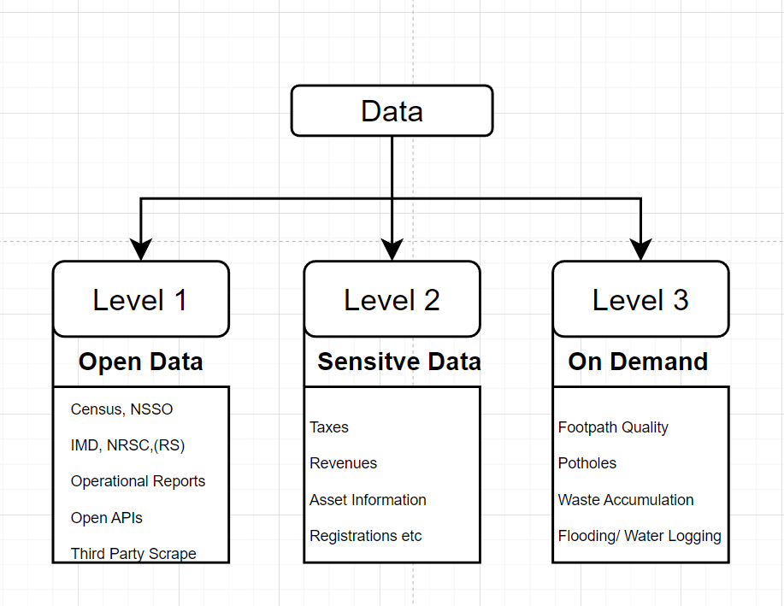

**L1: Open Access Data**

L1 data consists of publicly available information that is typically open but distributed across multiple formats. This data is foundational and provides a broad overview of the city's operational metrics.

Examples:

* Census Data: Demographic and socioeconomic data collected from residents.
* Annual Reports: PDFs and other documents from municipal bodies outlining yearly achievements, budget allocations, etc.
* Operational Reports: Documentation of city operations that may include utility usage, public transportation stats, etc.

**L2: Sensitive Government and Business Data**

L2 data is more confidential and typically restricted to internal use within government authorities or specific business entities. It includes detailed records that are crucial for financial and administrative purposes but are not made publicly accessible due to privacy or policy reasons.

Examples:

* Revenue Records: Data related to city revenues from taxes, licenses, and fees.
* Budgetary Allocations: Detailed breakdowns of financial distributions and expenditures by various city departments.
* Property Records: Information about property ownership, values, and related taxes, generally restricted due to privacy concerns.

**L3: Synthesized Data**

L3 data refers to information that does not currently exist in a readily accessible form and needs to be generated or estimated through analytical models or AI technologies such as computer vision. This data is often derived from analyzing existing datasets or by capturing new data types.

Example

* Pothole Detection: By utilizing high-resolution images of city streets, computer vision algorithms can identify and catalog the location and severity of potholes. This information is crucial for maintenance departments to prioritize repairs and improve road safety effectively.
* Footpath Quality Assessment: Similar to pothole detection, computer vision can be employed to assess the condition of footpaths across the city. This involves analyzing photographs or video data to identify cracks, uneven surfaces, or obstructions that could hinder pedestrian movement, especially for those with disabilities.
* Public Space Cleanliness: Using images from public surveillance cameras or captured from citizens, CV models can evaluate the cleanliness of public spaces such as parks, streets, and public squares. This data helps urban sanitation departments in scheduling cleaning and maintenance tasks more efficiently.
* Urban Greenery Health Monitoring: Computer vision techniques can be used to monitor the health of urban greenery by analyzing tree canopies in parks and streets. This includes detecting diseased trees, assessing tree coverage, and planning for greening efforts in under-served areas.

Functionalities -

**F1: Data Visualization and Statistical Analysis**

F1 focuses on the initial analysis and interpretation of collected data. This includes:

* Visualization: Creating intuitive and informative visual representations of data, such as graphs, heat maps, and interactive dashboards. These visuals help stakeholders quickly understand complex datasets and identify patterns or anomalies.
* Correlation Analysis: Examining the relationships between different data variables to understand how they influence one another. This helps in identifying potential connections that might not be immediately obvious.
* Causation Analysis: Going beyond correlation to determine if one variable directly affects another. This involves more sophisticated statistical techniques to differentiate between mere association and true causative relationships.
* Regression Analysis: Utilizing regression models to predict future outcomes based on current data. This method helps in understanding how various factors in the city’s data influence specific outcomes, aiding in more precise planning and decision-making.

**F2: Predictive Modeling and Simulation**

F2 advances the analytical process by applying the insights gained from F1 to model and predict future scenarios. Key activities include:

* Modeling: Developing mathematical models that represent the behavior of different urban systems based on the data analyzed in F1. These models can help simulate different conditions and their potential impacts on the city.
* Simulation: Running simulations based on these models to see how changes in one part of the system might affect others. This is crucial for testing potential decisions and planning urban development without real-world consequences.
* Prediction: Using predictive analytics to forecast future developments. This might include predicting traffic patterns, the impact of new policies on public health, or environmental changes. Predictions help city planners to proactively manage resources and prepare for upcoming challenges.

Together, F1 and F2 provide a comprehensive functionality for the City Truth Engine, enabling it to not only understand and analyze current urban data but also to anticipate and prepare for future developments effectively.

**User Profiles**

So who is going to use it?

1. **User Group 1** - Bureaucrats, High level decision makers

* Acts as a dashboard for monitoring and compliance

1. **User Group 2** - Everyday Ops officers

* Majorly function as a decision making aid

1. **User Group 3** - Civic action groups

* Primarily act as a supercharged data collection and analysis tool

1. **User Group 4** - Citizens

* Citizens who wants to keep their voice heard and are proactive in citizen participation initiatives

Application Layers

Ap1 - Will be standalone websites and URL links that are deployed as extensions to existing websites and environments. Possible examples include the URL looking either like

1. authority.com/cityaiengine [www.bbmp.gov.in/aiengine](http://www.bbmp.gov.in/aiengine)
2. [aiengine.com/town](http://aiengine.com/town)

How would this application layer look like?

The interface of the engine would strictly be a map first UI, and the compute and the application logic would also be the primary location first in nature.

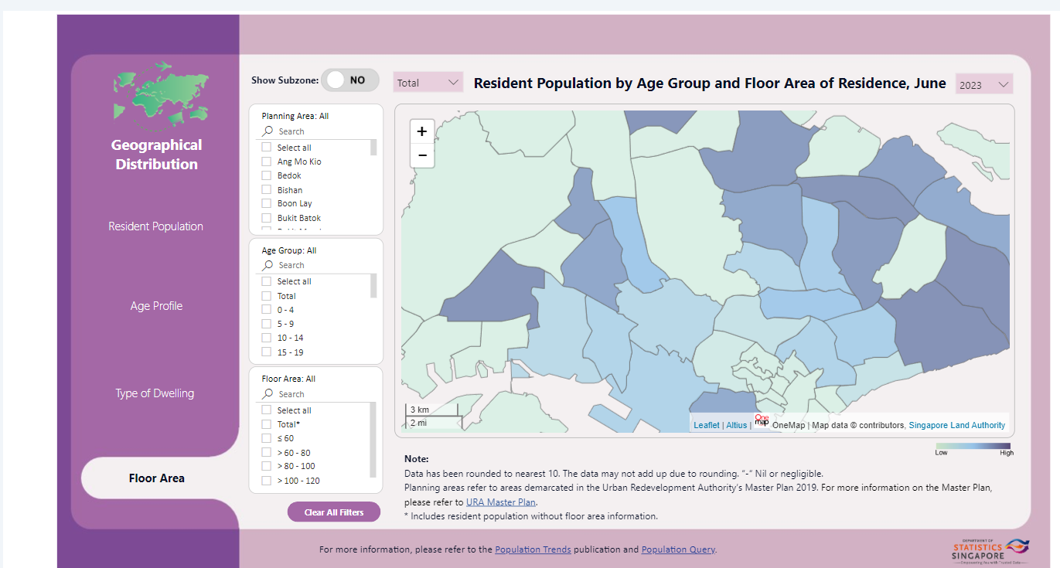

**AP2** - This application layer could be more on the administrator end, closely integrated within public service delivery and municipality modules , where the engine can sit in as sort of a plugin to modules that could be integrated into the existing governance modules. This could be an inward facing module of the engine where the methodology is delivered to the client stripping it off of aggregated attributes except the essentials like demographic and other core necessities

**Possibilities to unlock**

**Domain: Physical Infrastructure and Grievance Redressal**

* **L1 Data:** Reports on infrastructure issues like road damage, streetlights malfunctioning, or overflowing drainage systems (from websites, citizen hotlines)
* **L3 Data:** Integrate image recognition capabilities to analyze photos submitted by citizens depicting infrastructure problems.
* **F1 Functionality:**
  + Develop an interactive map dashboard (Ap1) where citizens can submit and track grievances related to physical infrastructure.
  + Utilize L3 data to automatically categorize the grievance (e.g., pothole, broken streetlight) and route it to the relevant department.
* **F2 Functionality:**
  + Implement sentiment analysis to gauge the severity of complaints based on citizen descriptions.
* **Outcome:** Efficient grievance registration, categorization, and routing to responsible authorities for faster resolution.

**Domain: Public Transport - Multimodal ( GMaps Public transport but better)**

* **L1 Data:** Public transport authority data on bus, metro, train schedules, routes, and ticket fares.
* **L2 Data (Optional):** Ridership information (requires permission from public transport authority).
* **L3 Data :** Congestion, Quality of transport, violations, public nuisance
* **F1 Functionality:** Develop a mobile app (Ap1) that allows citizens to:
  + Report issues like bus breakdowns, missed stops, or crowded buses.
  + Access real-time tracking information.
  + Analyze route efficiency using visualizations of ridership data (if L2 data is available).
* **Outcome:** Improved transparency and accountability of public transport services. Citizen feedback helps authorities identify and address issues promptly.

**Domain: Waste Management**

* **L1 Data:** Waste collection schedules and service area maps.
* **L2 Data** : Collection and operation reports
* **L3 Data:** Enable citizens to submit photos through the mobile app (Ap1) to report overflowing bins, missed collections, or illegal dumping.
* **F1 Functionality:** Develop a waste management dashboard (Ap1) where citizens can:
  + Report waste management issues with photo evidence.
  + Track the status of their grievances.
  + Access information on waste segregation and recycling guidelines.
* **Outcome:** Improved waste management through citizen participation. Geolocated reports with pictures help authorities identify problem areas and deploy resources effectively.

**Domain: Crime**

* **L1 Data:** Police reports on crime incidents (may require standardized reporting format).
* **L3 Data (Optional):** Analyze anonymized social media data for mentions of crime or public safety concerns (requires privacy safeguards).
* **F1 Functionality:** Develop a mobile app (Ap1) that allows citizens to:
  + Report crime incidents (with option to remain anonymous).
  + Access a safety heatmap that visualizes crime hotspots (based on L1 data).
* **Outcome:** Empower citizens to report crime and improve public safety awareness. Crime hotspot maps (based on anonymized data) can guide police patrolling strategies.

**Domain: Disasters**

* **L1 Data:** Weather forecasts, real-time flooding/disaster alerts from government agencies.
* L2 Data : Access to socio-political data to gauge vulnerability
* **L3 Data (Optional):** Integrate real-time data feeds from traffic cameras or social media to monitor disaster situations.
* **F1 Functionality:** Develop a multi-layered emergency response system (Ap1):
  + Disseminate real-time disaster alerts and evacuation instructions to citizens based on location.
  + Utilize L3 data for crowd-sourced traffic updates during disasters.
  + Provide citizens with access to emergency shelters and relief resources.
* **Outcome:** Improved disaster preparedness and response through real-time information sharing and citizen engagement.

**The Architecture :**

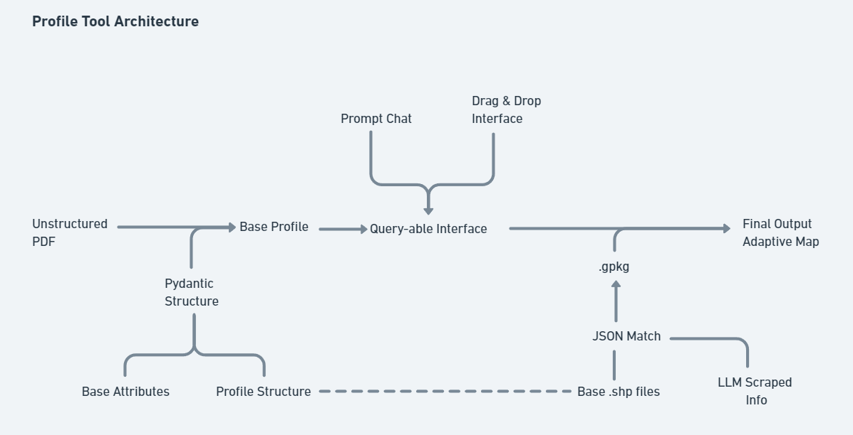

#### **Unstructured PDF to Base Profile Conversion**

The process begins with the ingestion of unstructured PDFs, often the primary format for city reports, records, and documentation. These documents are parsed and converted into a Base Profile using a Pydantic structure. Pydantic ensures that the extracted data adheres to a predefined schema, validating and standardizing the information for further processing. This step lays the foundation by organizing raw data into structured, machine-readable formats.

#### **2. Base Attributes and Profile Structure Extraction**

Once the Base Profile is established, the data is bifurcated into two core components: Base Attributes and Profile Structure. Base Attributes include essential metadata and key-value pairs that represent fundamental data points. Meanwhile, the Profile Structure encapsulates the broader context and relationships within the data. This separation allows for efficient data management, ensuring that critical attributes are readily accessible while maintaining the integrity of the overall profile.

#### **3. Query-able Interface**

The Base Profile feeds into a Query-able Interface, which serves as the central interaction point for users. This interface supports two primary modes of interaction:

* Prompt Chat: A conversational interface that allows users to query the system using natural language. This feature is particularly beneficial for non-technical users, enabling them to extract insights without needing to understand complex data structures.
* Drag & Drop Interface: A user-friendly feature that allows users to manipulate and visualize data by simply dragging and dropping elements. This enhances accessibility and empowers users to explore data in an intuitive manner.

#### **4. Integration with Geographic Data**

To create a spatially-aware output, the architecture integrates Base Profile data with geographic information system (GIS) files, specifically .shp (shapefiles). These files are matched with corresponding JSON data to form a comprehensive geospatial dataset. The integration process converts this data into the .gpkg (GeoPackage) format, which is efficient and capable of handling complex spatial data, ensuring the system can manage large datasets effectively.

#### **5. LLM-Scraped Information**

The architecture also incorporates information scraped by a Large Language Model (LLM). This data, extracted from various textual sources, enriches the Base Profile by adding contextual insights or filling in missing information. The LLM-scraped info is cross-referenced with existing data to enhance the accuracy and completeness of the final profile.

#### **6. Final Output: Adaptive Map**

The culmination of this process is the generation of a Final Output in the form of an Adaptive Map. This map is interactive and dynamic, providing a visual representation of the processed data. Users can engage with the map to explore various aspects of city management, such as infrastructure, public services, and resource allocation. The adaptive nature of the map allows it to update in real-time as new data is ingested, ensuring that it remains a current and accurate reflection of the city's status.

**The Architecture - Prototype 2**

#### **1. Image Input & Preprocessing Layer**

* **Input:**
  + The user provides an image of a footpath for analysis.
  + Input is captured via an image file (JPEG/PNG/etc.).
* **Preprocessing:**
  + **Image Resolution Check:** Validate if the image has sufficient clarity to identify footpath features. Low-resolution images trigger a request for better quality.
  + **Lighting & Orientation Adjustment:** Enhance brightness, contrast, and, if necessary, rotate the image for proper alignment.
  + **Image Segmentation:** Divide the image into zones (foreground, background, street, footpath) to better isolate elements of interest, like sidewalks, crossings, trees, etc.

#### **2. Object Detection & Feature Extraction Layer**

* **Model Inference:**
  + **AI Model:** Use pre-trained object detection models (e.g., YOLO, Mask R-CNN) to detect key elements in the image, such as:
    - **Footpath Boundaries** (pavement edges)
    - **Street Furniture** (benches, bollards)
    - **Traffic Signage & Crossings** (zebra crossings, road signs)
    - **Canopy Cover** (trees, shading elements)
    - **CCTV Cameras**
    - **Accessibility Features** (ramps, tactile paving)
    - **Traffic Calming Measures** (speed bumps, dividers)
    - **Pedestrian Flow Elements** (divided lanes, curb cuts)
* **Bounding Box & Feature Mapping:**
  + Objects identified are localized with bounding boxes and annotated for further processing. For example, a detected bench is marked with a bounding box and labeled as "bench."

#### **3. Parameter Evaluation & Scoring Layer - Link to the document here :** [**Walkability Parameters**](https://docs.google.com/document/d/1qsvb8ivyuiFPcWaEqsB9P0f7YRd8LtOiJfrhCupGxG8/edit)

* **Footpath Quality:**
  + **Surface Condition Analysis:** Evaluate the pavement for cracks, potholes, uneven surfaces, or obstructions. This includes checking for materials like cobblestones or smooth asphalt.
  + **Space Evaluation:** Measure the width of the footpath for pedestrian movement, checking for crowding issues.
* **Accessibility Features:**
  + **Ramps & Tactile Paving:** Identify the presence of accessibility features like ramps at crossings and tactile paving for the visually impaired.
  + **Smooth Transitions:** Assess the presence of curb cuts and level transitions for wheelchairs and strollers.
* **Aesthetic Appeal:**
  + **Visual Elements:** Identify greenery (trees, plants), public art, and design consistency. Higher aesthetic scores are given for visually pleasing elements.
  + **Cleanliness:** Evaluate the presence of litter, graffiti, or other detractors from the aesthetic quality.
  + **Lighting Presence:** Detect street lights, checking for adequate illumination for night-time walking.
* **Safety Features:**
  + **CCTV Cameras:** Detect the presence of surveillance cameras and position them relative to pedestrian traffic zones.
  + **Crossings & Calming Measures:** Identify zebra crossings, speed bumps, and pedestrian islands that improve footpath safety.

#### **4. Post-Processing & Normalization Layer**

* **Parameter Weighting:** 
  + Weight parameters based on walkability importance:
    - **Footpath Quality:** 30%
    - **Accessibility Features:** 25%
    - **Safety & Security:** 20%
    - **Aesthetic Appeal:** 15%
    - **Street Furniture & Amenities:** 10%
* **Normalization:** Standardize scores across parameters to ensure consistency. For example, if "Footpath Quality" is marked as 70%, normalize this relative to other footpath evaluations.
* **Composite Scoring:** Generate a final composite score that aggregates individual parameter scores. This score helps in ranking the footpath's overall condition.

#### **5. Data Output Layer**

* **Table Generation:**
  + Convert the processed data into clear, structured tables showing:
    - **Parameter:** (e.g., Footpath Quality, Accessibility, Aesthetic Appeal)
    - **Assessment:** (e.g., "Good," "Moderate," "Poor")
    - **Explanation:** Detailed notes explaining the observations.
* **Scorecard Visualization:**
  + Create a visual scorecard (e.g., bar charts, radar graphs) for easier comparison of footpath assessments.
* **Textual Report:**
  + Provide a professional report summarizing key findings, areas for improvement, and recommendations for urban planners.

#### **6. Feedback & Iteration Layer**

* **Feedback Loop:**
  + If some areas of the footpath were not clear in the image, request additional images or clarifications from the user.
* **Iterative Improvements:**
  + Based on user input, retrain models to handle more nuanced or specific urban planning elements (e.g., identifying sustainable drainage solutions or advanced accessibility features).
* **Version Control:**
  + Keep track of changes in algorithms and methodologies, iterating as new city guidelines or urban planning standards evolve.

**Data Syntax**

* **{**
* **"type": "FeatureCollection",**
* **"features": [**
* **{**
* **"type": "Feature",**
* **"geometry": {**
* **"type": "Point",**
* **"coordinates": [77.5946, 12.9716]**
* **},**
* **"properties": {**
* **"image": "Xxxx.jpeg",**
* **"score": 85**
* **}**
* **}**
* **]**
* **}**

1. Could we do some query in natural language that converts the query in GeoJSON and shows the output in some map format. Could be like one Google Search kind of interface for the city - for example the utterance could be -
   1. Show me the location of all the potholes in 2 km radius of “Indira Nagar” and tell me
      1. Who should I reach out to for the the repair
      2. Who is the responsible stakeholder
      3. How many potholes were detected/data uploaded in last 1 month